

Computer Science Fundamental and Career Pathways

LAB ASSIGNMENT 5

Name: Yash Vats
Section: B
Course: B. Tech CSE AI & ML
Roll Number: 2501730060
Date of Submission: 28 Nov 2025
Submitted to: Mr. Aryaan Sharma

Problem Definition
Study Planner system that takes inputs (subject names, total hours, deadlines), creates daily plans (max 2 hours/subject to avoid burnout), tracks progress, sends overdue reminders, and confirms completion.
_______________________________________________________________
Pseudocode Algorithm
BEGIN StudyPlanner
INPUT number_of_subjects, subject_list[], total_hours[], deadlines[]
FOR each subject i:
remaining_hours[i] = total_hours[i]
WHILE any remaining_hours > 0:
current_date = today
daily_plan = []
FOR each subject i:
IF remaining_hours[i] > 0 AND deadline[i] > current_date:
session_hours = MIN(2, remaining_hours[i]) // Max 2hr/session
ADD "Study subject[i] for session_hours hours" to daily_plan
remaining_hours[i] = remaining_hours[i] - session_hours
OUTPUT daily_plan
IF overdue_tasks exist:
OUTPUT "Reminder: Complete overdue tasks for subject X"
current_date = current_date + 1 day
OUTPUT "All study goals completed!"
END
_______________________________________________________________________

Flowchart
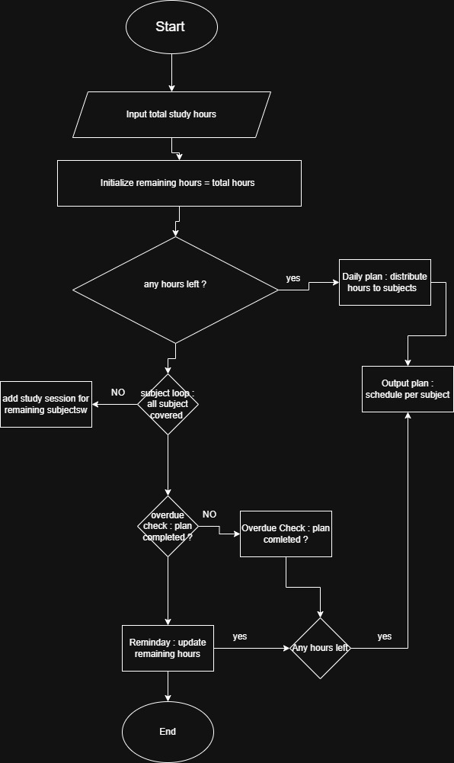
___________________________________________________________________________________________________

Gitbash Command
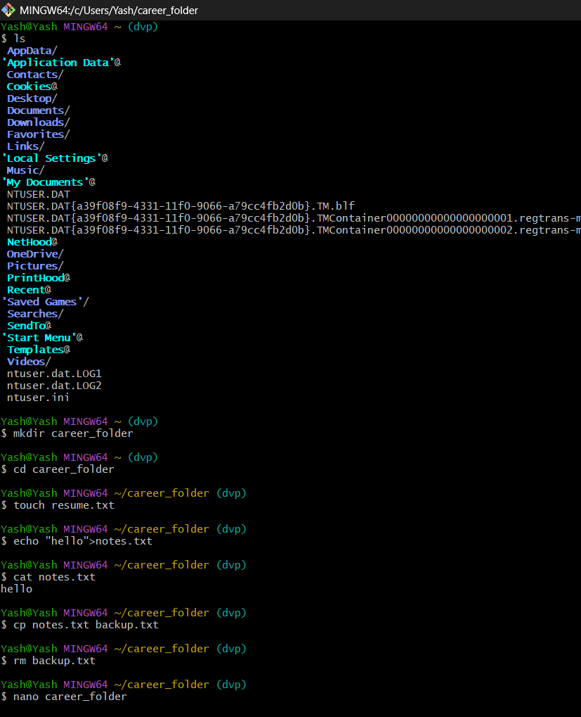
_______________________________________________________________________________________________________
Infographic
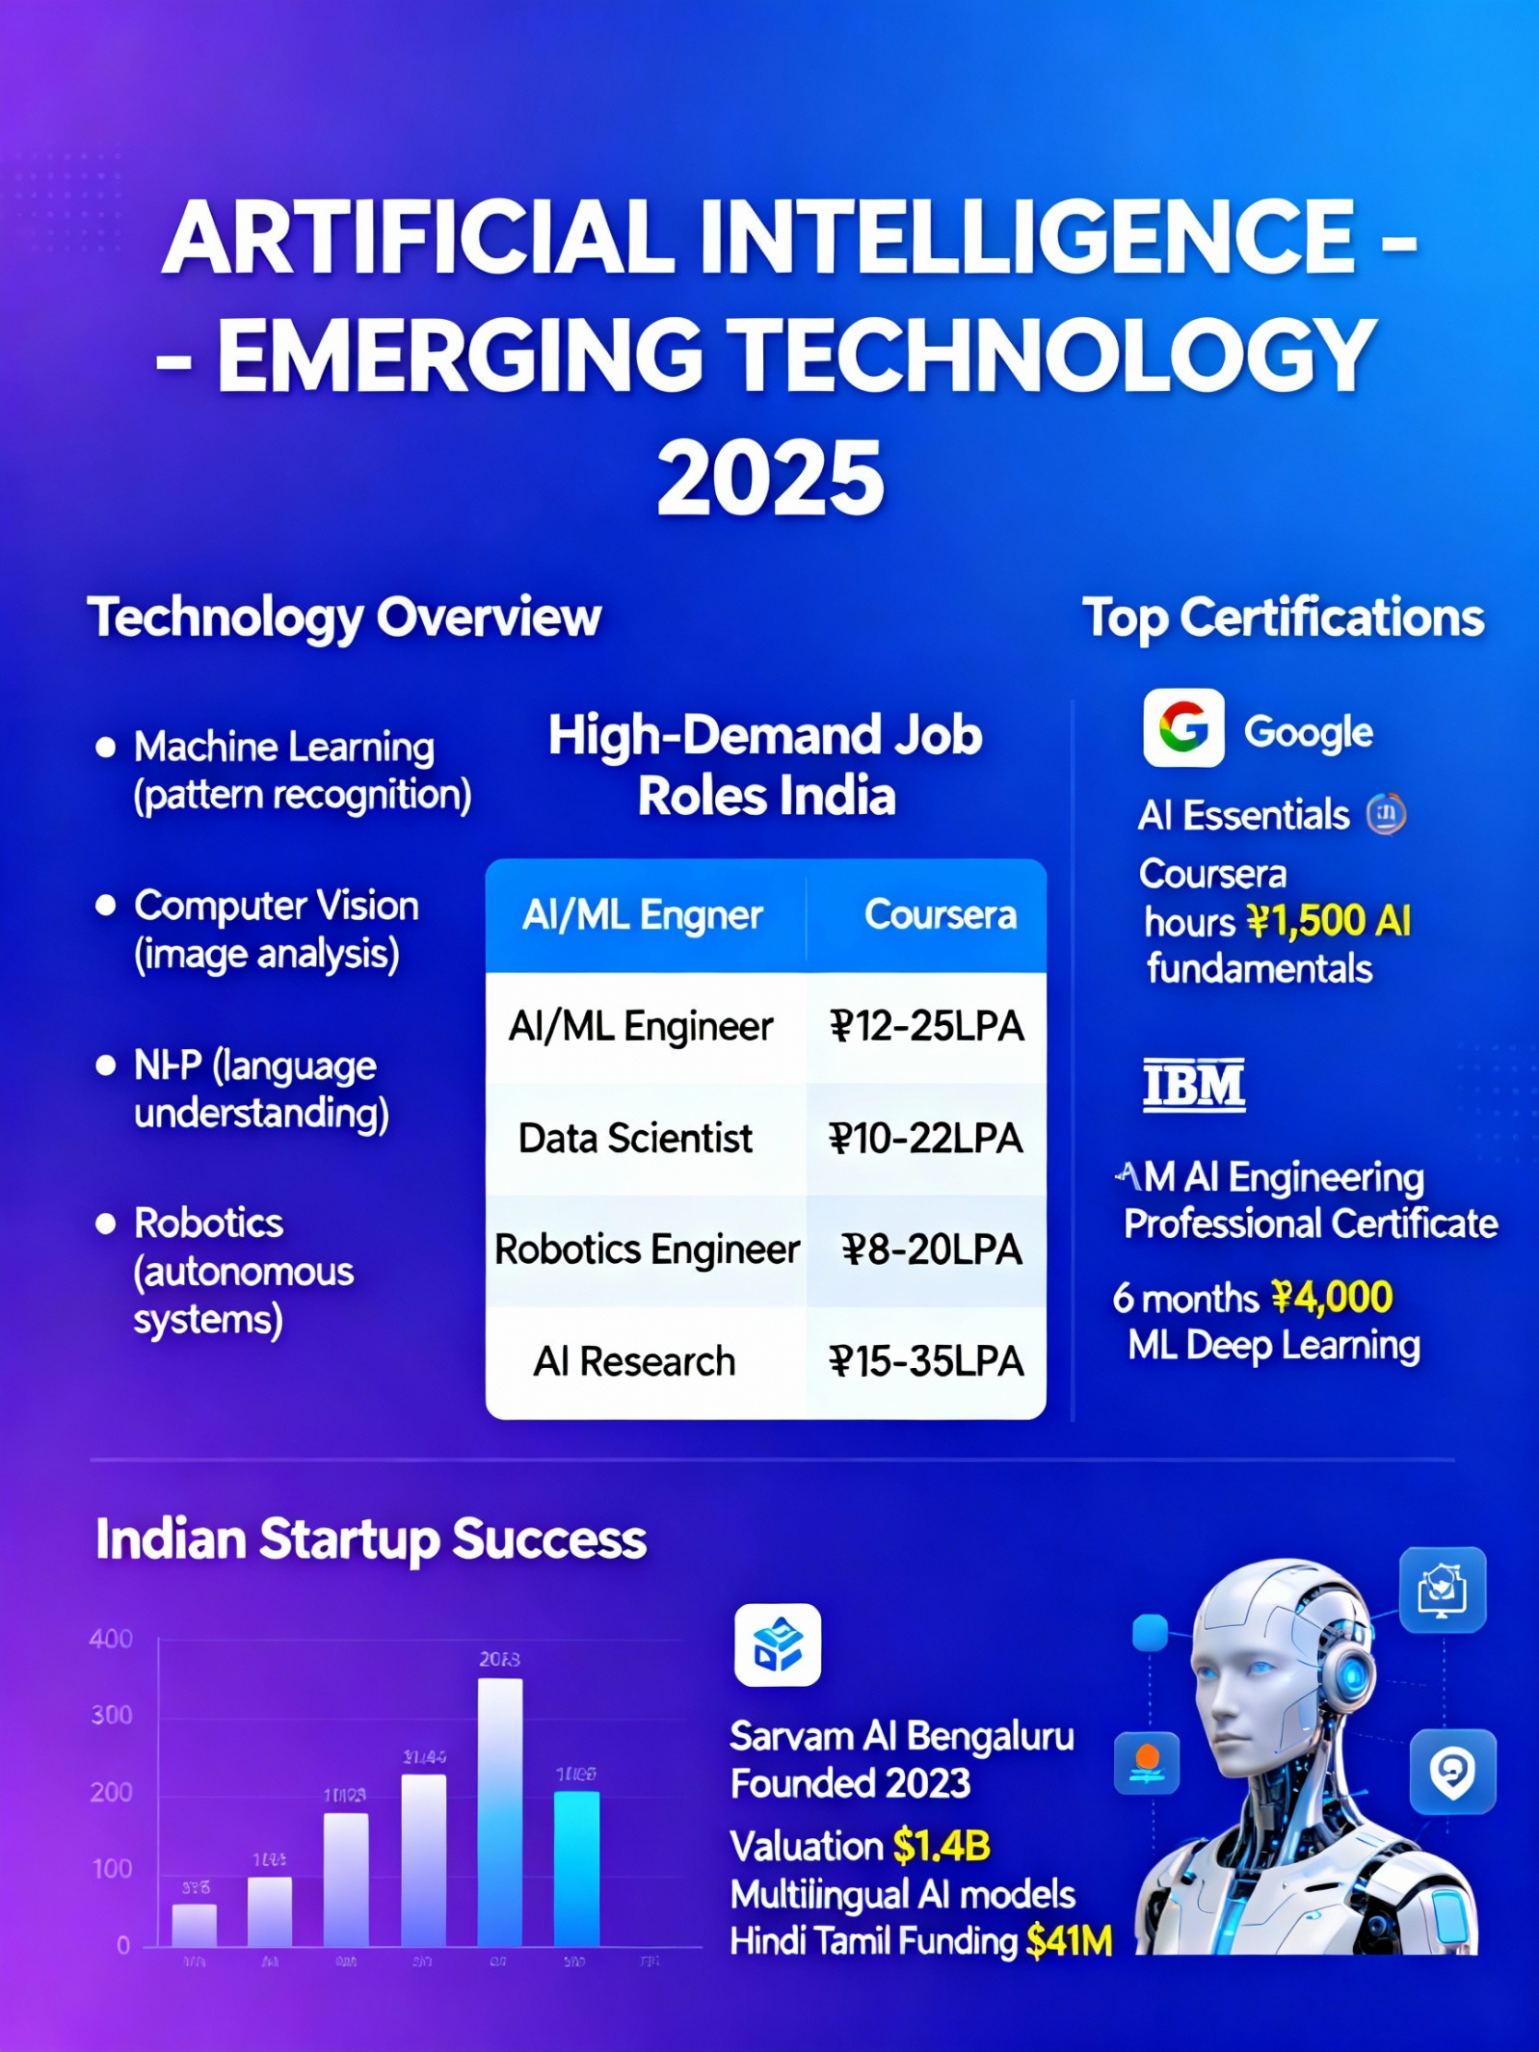
_______________________________________________________________________________________________________
Smart goals
1. Short-term (6 months - By June 2026)
Specific: Complete Google AI Essentials certification on Coursera
Measurable: 100% course completion + certificate earned
Achievable: 10 hours total, 2hrs/week alongside semester
Relevant: Builds AI foundation for my specialization
Time-bound: Finish by 30th June 2026
2. Medium-term (2 years - By Dec 2027)
Specific: Build and deploy 3 AI/Robotics projects on GitHub
Measurable: 1) Study Planner app, 2) Object detection robot, 3) Chatbot
Achievable: 1 project/semester using college labs
Relevant: Creates portfolio for internships
Time-bound: All 3 projects live by Dec 2027​
3. Long-term (4 years - By Graduation 2029)
Specific: Secure AI/ML internship at Indian startup
Measurable: 6-month paid internship, ₹30k+/month stipend
Achievable: Apply to 50+ companies via LinkedIn/Internshala
Relevant: Gain industry experience before full-time role
Time-bound: Start internship by June 2029
_____________________________________________________________

Certifications
1. Google AI Essentials (Coursera)
- Provider: Google
- Duration: 10 hours (self-paced)
- Cost: ₹1,500
- Skills: AI fundamentals, prompt engineering
- Alignment: SMART Goal #1​
2. IBM AI Engineering Professional Certificate
- Provider: IBM/Coursera
- Duration: 6 months (5hrs/week)
- Cost: ₹4,000
- Skills: ML, Deep Learning, Scalable AI
- Alignment: SMART Goal #2 projects
_______________________________________________________________
Linkedin Updates
Profile link : Yash's Linkedin
_______________________________________________________________
Career roadmap
My 4-year B.Tech AI & ML career roadmap begins with Year 1 (2025-26) foundation building, mastering Python, Data Structures, Linux, and Git through coursework and personal projects like this Study Planner. I'll complete Google AI Essentials certification by June 2026, maintain GPA 8.5+, and participate in 1 coding contest to build competitive programming skills essential for technical interviews.​
Year 2 (2026-27) focuses on AI/ML specialization with Machine Learning electives and IBM AI Engineering certification completion. I'll develop 2 GitHub projects—a sentiment analysis chatbot using NLP and image classification model—while joining 2 hackathons like ICDCIT 2026. Summer brings my first unpaid internship at a local AI startup to gain real-world exposure to model deployment pipelines.​
Year 3 (2027-28) emphasizes portfolio strengthening through open-source contributions to ML libraries like TensorFlow and advanced courses in Deep Learning and Computer Vision. A 6-month paid internship (₹25k+ stipend) at companies like Sarvam AI or Fractal Analytics becomes priority, alongside leadership roles in college AI/ML clubs to develop team management skills crucial for industry roles.​
Year 4 (2028-29) culminates in capstone project development—an AI-powered predictive analytics system for healthcare or finance—while applying to 50+ companies for AI/ML Engineer positions targeting ₹12-18 LPA packages. Backup plan includes MS applications to US universities (IISc Bangalore, IITs) if premium offers aren't secured. By graduation, my portfolio will feature 5 ML projects, 3 certifications, 2 internships, and 3 hackathon experiences positioning me strongly in India's booming AI job market.​
This roadmap aligns perfectly with market demand—India needs 1 million AI professionals by 2026—while leveraging my university's industry connections and placement cell. Regular progress tracking through quarterly reviews ensures I stay on course toward becoming a skilled AI/ML Engineer contributing to India's tech innovation ecosystem.​​

